Project Design Phase-II

Technology Stack (Architecture & Stack)
Date: 28 February 2026
Team ID: LTVIP2026TMIDS60852
Project Name: Dream Nest – House Rent, Vacation & Villa Booking Platform
Maximum Marks: 4 Marks

Technical Architecture
Dream Nest follows a 3-tier architecture consisting of a Client Layer (Frontend), Application Layer (Backend APIs), and Database Layer. The system ensures secure authentication, efficient state management, and scalable data storage.
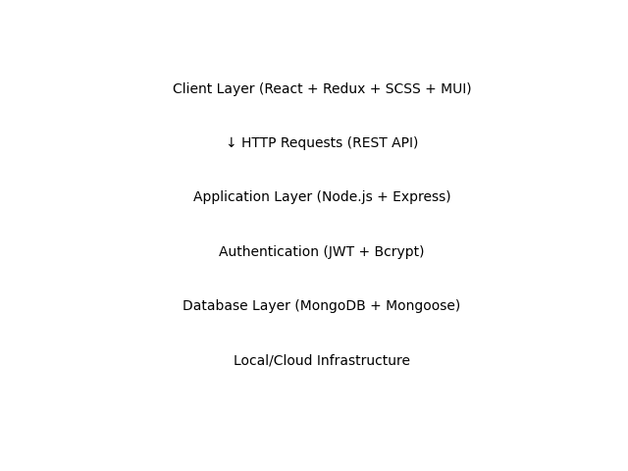

Table-1: Components & Technologies
S.No | Component | Description | Technology
1 | User Interface | Web-based platform for browsing, searching, booking properties and managing listings. | React.js, Redux, SCSS, Material UI
2 | Application Logic (Backend) | Handles REST APIs, business logic, authentication, booking flow, and property management. | Node.js, Express.js
3 | Authentication & Security | Secure login and registration with encrypted passwords and token-based authentication. | JWT, Bcrypt
4 | Database | Stores user data, property listings, bookings, and wishlist information. | MongoDB, Mongoose
5 | File Storage | Stores uploaded property images from local system. | MongoDB / Local Storage
6 | API Communication | Handles frontend-backend communication through RESTful APIs. | Axios / Fetch API
7 | State Management | Maintains global application state and real-time UI updates. | Redux
8 | Infrastructure | Deployment and hosting environment. | Local Server / Cloud Deployment

Table-2: Application Characteristics
S.No | Characteristics | Description | Technology
1 | Open-Source Frameworks | Modern JavaScript-based frontend and backend frameworks. | React.js, Node.js
2 | Security Implementation | Token-based authentication and encrypted password storage. | JWT, Bcrypt
3 | Scalable Architecture | Modular 3-tier architecture separating UI, logic, and database. | MERN Stack
4 | Availability | Accessible via web browsers with minimal downtime. | Cloud / Web Hosting
5 | Performance | Optimized rendering, fast API response, and efficient database queries. | Redux Optimization, Indexed Queries

